Title:
Write a program for error detection and correction for 7/8 bits ASCII codes using Hamming
Codes or CRC. Demonstrate the packets captured traces using Wireshark Packet Analyzer
Tool for peer to peer mode.( 50% students will perform Hamming Code and others will
perform CRC) (Use C/C++)
CODE:
RECEIVER.CPP:
// receiver.cpp
// Usage: ./receiver <listen_port>
// Example: ./receiver 5005

#include <bits/stdc++.h>
#include <arpa/inet.h>
#include <sys/socket.h>
#include <unistd.h>
using namespace std;

// CRC16 (same as sender)
uint16_t crc16_ccitt(const vector<uint8_t>& data) {
uint16_t crc = 0xFFFF;
for (uint8_t b : data) {
crc ^= (uint16_t)b << 8;
for (int i = 0; i < 8; ++i) {
if (crc & 0x8000) crc = (crc << 1) ^ 0x1021;
else crc <<= 1;
}
}
return crc & 0xFFFF;
}

vector<int> unpack_bits_from_bytes(const vector<uint8_t>& bytes, int bitcount) {
vector<int> bits(bitcount);
for (int i = 0; i < bitcount; ++i) bits[i] = (bytes[i/8] >> (i%8)) & 1;
return bits;
}

// decode hamming: returns pair(corrected_byte_value, status_string)
pair<int,string> decode_hamming_bits(const vector<int>& encoded_bits) {
int n = encoded_bits.size();
// compute r (num parity bits)
int r = 0;
while ((1<<r) <= n) ++r;
// compute syndrome
int syndrome = 0;
for (int i = 0; i < r; ++i) {
int ppos = 1 << i;
int parity = 0;
for (int j = 1; j <= n; ++j) {
if (j & ppos) parity ^= encoded_bits[j-1];
}
if (parity) syndrome |= ppos;
}
vector<int> corrected = encoded_bits;
if (syndrome != 0) {
if (syndrome <= n) {
// flip bit
corrected[syndrome-1] ^= 1;
} else {
// impossible, but mark
}
}
// extract data bits from non-power positions:
vector<int> data_bits;
for (int i = 1; i <= n; ++i) {
if ((i & (i-1)) != 0) data_bits.push_back(corrected[i-1]);
}
// form byte value (LSB-first in data_bits)
int val = 0;
for (int i = 0; i < (int)data_bits.size(); ++i) {
val |= (data_bits[i] & 1) << i;
}
string status;
if (syndrome == 0) status = "OK (no error)";
else {
// Check if double-bit error: re-calc parity overall: if parity checks fail, detect
// For Hamming single-bit correction we treat syndrome!=0 as single-bit error corrected
status = "Single-bit error detected and corrected at position " + to_string(syndrome);
}
return {val, status};
}

int main(int argc, char** argv) {
if (argc < 2) {
cerr << "Usage: " << argv[0] << " <listen_port>\n";
return 1;
}
int port = atoi(argv[1]);
int sock = socket(AF_INET, SOCK_DGRAM, 0);
if (sock < 0) { perror("socket"); return 1; }
sockaddr_in addr{};
addr.sin_family = AF_INET;
addr.sin_port = htons(port);
addr.sin_addr.s_addr = INADDR_ANY;
if (bind(sock, (sockaddr*)&addr, sizeof(addr)) < 0) { perror("bind"); return 1; }
cout << "Listening on UDP port " << port << "...\n";

while (true) {
uint8_t buf[65536];
sockaddr_in src{};
socklen_t slen = sizeof(src);
ssize_t len = recvfrom(sock, buf, sizeof(buf), 0, (sockaddr*)&src, &slen);
if (len <= 0) continue;
vector<uint8_t> pkt(buf, buf + len);
if (pkt.size() < 4) continue;
char mode = (char)pkt[0];
int ascii_bits = pkt[1];
int payload_len = (pkt[2] << 8) | pkt[3];
if ((int)pkt.size() < 4 + payload_len) {
cout << "Truncated packet\n";
continue;
}
vector<uint8_t> payload(pkt.begin() + 4, pkt.begin() + 4 + payload_len);
cout << "Received packet from " << inet_ntoa(src.sin_addr) << ":" << ntohs(src.sin_port)
<< " mode=" << mode << " ascii_bits=" << ascii_bits
<< " payload_len=" << payload_len << "\n";

string reconstructed;
size_t pos = 0;
if (mode == 'H') {
while (pos < payload.size()) {
int enc_bitcount = payload[pos++];
int bytes_needed = (enc_bitcount + 7) / 8;
if (pos + bytes_needed > payload.size()) break;
vector<uint8_t> enc_bytes(payload.begin()+pos, payload.begin()+pos+bytes_needed);
pos += bytes_needed;
auto bits = unpack_bits_from_bytes(enc_bytes, enc_bitcount);
auto pr = decode_hamming_bits(bits);
int chval = pr.first & 0xFF;
reconstructed.push_back((char)chval);
cout << "Decoded char '" << (isprint(chval)? (char)chval : '?')
<< "' (" << chval << ") -> " << pr.second << "\n";
}
} else if (mode == 'C') {
while (pos + 3 <= payload.size()) {
uint8_t ch = payload[pos++];
uint16_t rx_crc = (payload[pos++] << 8);
rx_crc |= payload[pos++];
vector<uint8_t> v{ch};
uint16_t calc = crc16_ccitt(v);
if (calc == rx_crc) {
reconstructed.push_back((char)ch);
cout << "CRC OK for '" << (isprint(ch)?(char)ch:'?') << "' (" << (int)ch << ")\n";
} else {
cout << "CRC FAIL for byte " << (int)ch << " received crc=0x" << hex << rx_crc
<< " calc=0x" << calc << dec << "\n";
reconstructed.push_back('?'); // placeholder
}
}
} else {
cout << "Unknown mode\n";
}
cout << "Reconstructed message: \"" << reconstructed << "\"\n\n";
}

close(sock);
return 0;
}
SENDER.CPP
// sender.cpp
// Usage: ./sender <peer_ip> <peer_port> <mode> <7|8>
// mode: H for Hamming, C for CRC
// Example: ./sender 192.168.1.10 5005 H 7
// Example: ./sender 127.0.0.1 5005 C 8

#include <bits/stdc++.h>
#include <arpa/inet.h>
#include <sys/socket.h>
#include <unistd.h>

using namespace std;

// ---------------- CRC-16-CCITT ----------------
uint16_t crc16_ccitt(const vector<uint8_t>& data) {
uint16_t crc = 0xFFFF;
for (uint8_t b : data) {
crc ^= (uint16_t)b << 8;
for (int i = 0; i < 8; ++i) {
if (crc & 0x8000) crc = (crc << 1) ^ 0x1021;
else crc <<= 1;
}
}
return crc & 0xFFFF;
}

// ---------------- Hamming encoder for 7 or 8 bits ----------------
// Place parity bits at positions that are powers of two (1-based).
// For m data bits and r parity bits where 2^r >= m + r + 1

vector<int> int_to_bits(uint8_t val, int bits) {
vector<int> out(bits);
for (int i = 0; i < bits; ++i) out[i] = (val >> i) & 1;
return out;
}

uint8_t bits_to_byte(const vector<int>& bits, int start) {
uint8_t b = 0;
for (int i = 0; i < 8 && start + i < (int)bits.size(); ++i)
b |= (bits[start + i] & 1) << i;
return b;
}

vector<int> encode_hamming_bits(const vector<int>& data_bits) {
int m = data_bits.size();
int r = 1;
while ((1 << r) < (m + r + 1)) ++r;
int n = m + r;
vector<int> out(n+1, 0); // 1-based indexing for simplicity
// fill data bits into non-power positions
int data_idx = 0;
for (int i = 1; i <= n; ++i) {
if ((i & (i-1)) != 0) { // not power of two
out[i] = data_bits[data_idx++];
}
}
// compute parity bits
for (int i = 0; i < r; ++i) {
int ppos = 1 << i;
int parity = 0;
for (int j = 1; j <= n; ++j) {
if (j & ppos) parity ^= out[j];
}
out[ppos] = parity;
}
// return 0-based vector
vector<int> res(n);
for (int i = 0; i < n; ++i) res[i] = out[i+1];
return res;
}

// Pack a vector<int> bits into bytes (LSB-first in each byte)
vector<uint8_t> pack_bits_to_bytes(const vector<int>& bits) {
int n = bits.size();
int bytes = (n + 7) / 8;
vector<uint8_t> out(bytes, 0);
for (int i = 0; i < n; ++i) {
if (bits[i]) out[i/8] |= (1 << (i%8));
}
return out;
}

int main(int argc, char** argv) {
if (argc < 5) {
cerr << "Usage: " << argv[0] << " <peer_ip> <peer_port> <mode H|C> <7|8>\n";
return 1;
}
string peer_ip = argv[1];
int peer_port = atoi(argv[2]);
char mode = argv[3][0];
int ascii_bits = atoi(argv[4]);
if (!(mode=='H' || mode=='C')) { cerr<<"mode H or C\n"; return 1; }
if (!(ascii_bits==7 || ascii_bits==8)) { cerr<<"7 or 8 bits\n"; return 1; }

int sock = socket(AF_INET, SOCK_DGRAM, 0);
if (sock < 0) { perror("socket"); return 1; }

sockaddr_in peer{};
peer.sin_family = AF_INET;
peer.sin_port = htons(peer_port);
inet_pton(AF_INET, peer_ip.c_str(), &peer.sin_addr);

cout << "Enter a line to send (empty line to quit):\n";
string line;
while (true) {
getline(cin, line);
if (line.size() == 0) break;

// Build packet: header [mode 'H'/'C', ascii_bits (1 byte), payload length (2 bytes)] then payload bytes
vector<uint8_t> payload;

for (unsigned char ch : line) {
uint8_t ch8 = (uint8_t)ch;
vector<int> data_bits;
for (int i = 0; i < ascii_bits; ++i) data_bits.push_back((ch8 >> i) & 1);
if (mode == 'H') {
auto encoded_bits = encode_hamming_bits(data_bits); // e.g., 11 or 12 bits
auto packed = pack_bits_to_bytes(encoded_bits);
// Prepend a single byte indicating how many encoded bits (for decoding)
payload.push_back((uint8_t)encoded_bits.size());
payload.insert(payload.end(), packed.begin(), packed.end());
} else { // CRC
// send original byte, then append CRC per-character (or we can append one CRC for whole message)
// Here we append per-character CRC for clarity in packet trace.
vector<uint8_t> v{ch8};
uint16_t crc = crc16_ccitt(v);
payload.push_back(ch8);
payload.push_back((crc >> 8) & 0xFF);
payload.push_back(crc & 0xFF);
}
}

// Packet header
vector<uint8_t> pkt;
pkt.push_back((uint8_t)mode);
pkt.push_back((uint8_t)ascii_bits);
uint16_t payload_len = payload.size();
pkt.push_back((payload_len >> 8) & 0xFF);
pkt.push_back(payload_len & 0xFF);
pkt.insert(pkt.end(), payload.begin(), payload.end());

// send
ssize_t sent = sendto(sock, pkt.data(), pkt.size(), 0, (sockaddr*)&peer, sizeof(peer));
if (sent < 0) perror("sendto");
else cout << "Sent " << sent << " bytes\n";
}

close(sock);
cout << "Sender exiting.\n";
return 0;
}

OUTPUT:
WINDOW1:
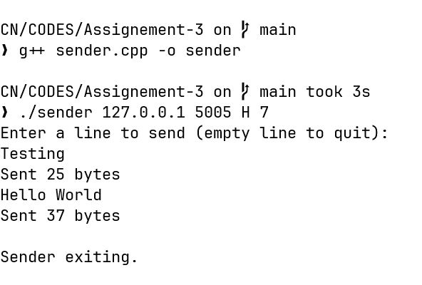

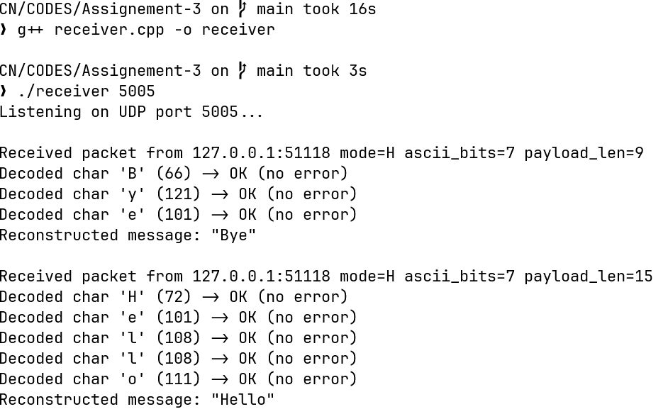
WINDOW 2:

